Celestial Navigation: Lesson Plan
By Matt Laird and Heather Murphy
Last Modified July 2019
Subject:
STEM
Physics
Chemistry
Earth and Space
Astronomy

Grade:
7th, 8th, 9th grade students.

Time:
5 Class Periods

Standard(s): These performance expectations have been directly taken from the Next Generation Science Standards website at https://www.nextgenscience.org/.
MS-ESS1-3: Analyze and interpret data to determine scale properties of objects in the solar system.
MS-ETS1-3: Evaluate competing design solutions using a systematic process to determine how well they meet the criteria and constraints of the problem.
MS-ETS1-4: Develop a model to generate data for iterative testing and modification of proposed object, tool, and process such that an optimal design can be achieved.
HS-ETS1-3: Evaluate a solution to a complex real-world problem based on prioritized criteria and trade-offs that account for a range of constraints, including cost, safety, reliability, and aesthetics, as well as possible social, cultural, and environmental impacts.

Connections to Prior Learning:

- Electromagnetic Spectrum (See Multiwavelength Astronomy: Lesson Plan)
- Space, the Universe, Celestial Objects (See: Star Evolution and Gamma Ray Sources: Lesson Plan)
- HAWC Detector (See Cosmic Gamma Rays: Lesson Plan)
- Observing Radiation (See Multiwavelength Astronomy: Lesson Plan)
- Cross Curricular connection to mapping in Geography.
- Technical skills on reading and interpreting a protractor.

Concept/Topic to Teach:

- Analyze and interpret data from celestial coordinate systems.
- Compare and Contrast different celestial coordinate systems.
- Design and evaluate a model of a celestial coordinate system (Planetarium).
- Analyze and interpret Gamma-ray constellations.
Specific Objectives: Student will be able to:

- Describe and identify various celestial objects that inhabit the universe.
- Analyze and interpret data from maps.
- Demonstrate grade-appropriate proficiency in planning and carrying out investigations, designing solutions, developing and using models, and obtaining, evaluating, and communicating information.
- Formulate data form a non-traditional source (Fermi Gamma-ray constellations) into a conventional application.
Lesson Relevance:

- Appraisal of the universe and its features both galactic and extragalactic.
- Identify how astronomers determine information about the universe.
- Summarize the importance of using different tools and instruments to understand the universe

Cross Curriculum Connections:

- English/ Social Studies: Student could create Mythical stories to accompany the Gamma-ray Constellations found on https://fermi.gsfc.nasa.gov/science/constellations/ in the Explore stage of this lesson.

Required Materials:

- Computer with Projector
- Internet Access
- Available resources (See attached Available Resources Cost sheet) Note: The resources provided to the students from the school may vary.
- Engineering Design Process Scoring Rubric
- Protractor for each student
Technology:
- Using a protractor to find angles
- Tracing points on a coordinate system on a computer
- Using mathematical software like Google Sheets to convert between coordinate systems (Extension for advanced students)
Modification/Accommodation(ELL/IEP students):
- Guided notes/Printed Google Slides Presentation
- Reduction of Assignment.
- Additional time for the assignment.
- List of useful Vocabulary
- Pairing with strong anchor students for projects
Reteach/Extensions(struggling/advanced students):
- Reteach/Extensions ideas are indicated throughout the lesson plans.

Instructional Procedure: Engage
Heading: Celestial Scavenger Hunt Local Coordinate

Goal of the Day
- Students will be able to interpret and implement maps and directions to identify objects within the classroom.
Advance Preparation:
- Bell ringer on the board: How do you describe an object's location?
- Teacher will need a compass to mark North in the classroom with an X or a Star.
- Teacher will need to mark the center of the ceiling in the center of the classroom with an X or a Star.
- Each student will need a protractor.
Background Information (Lesson Introduction):

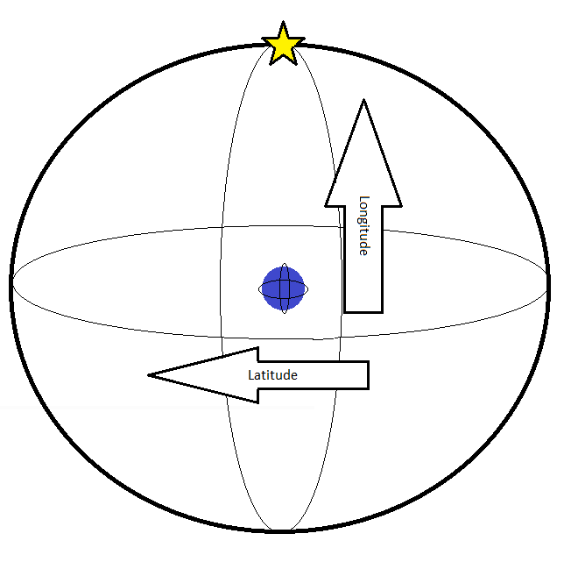
Procedure/Strategies:
- Engage: (10 min): (Note: The following activity is a generic version of the scavenger hunt, it is intended to be customized to fit the restrains of the classroom.)

Directions:
For this activity set North in your classroom as the zero point for the Longitudinal scale (The teacher should mark this point with an X or a Star). This will be your local meridian point. From this point turn 360 degrees to the east (right). You should find yourself back at the X (facing North).
For this activity the floor in your classroom is the zero point for the Latitude scale. The center of the ceiling in your classroom will be 90 degrees. (The teacher should mark this point with an X or a Star). Your local zenith point.
Questions:
- What is an object at a longitude of 90 degrees, at any latitude? ____________________
- What is an object at a longitude of 270 degrees, at any latitude? ____________________
- What is an object at a longitude of 0 degrees, and a latitude of 45 degrees? ____________________
- What is an object at a longitude of 180 degrees, and a latitude of 45 degrees? ____________________
- What would be the coordinate for the door? ____________________
- What would be the coordinate for the window? ____________________
- What would be the coordinate for the fire extinguisher? ____________________
- What would be the coordinate for the eyewash station? ____________________
- What would be the coordinate for the fire blanket? ____________________
- Extra credit: What would be the coordinate for your home? ____________________

Key Vocabulary and Academic Vocabulary:

- Declination: the angular distance of a heavenly body from the celestial equator, measured on the great circle passing through the celestial pole and the body.
- Celestial Longitude: the angular distance of a point on the celestial sphere from the great circle that is perpendicular to the ecliptic at the point of the vernal equinox, measured through 360° eastward parallel to the ecliptic.
- Latitude: the angular distance north or south from the equator of a point on the earth's surface, measured on the meridian of the point.
- Longitude: angular distance east or west on the earth's surface, measured by the angle contained between the meridian of a particular place and some prime meridian, as that of Greenwich, England, and expressed either in degrees or by some corresponding difference intime.
- Meridian: a great circle of the earth passing through the poles and any given point on the earth's surface.
- Protractor: an instrument for measuring angles, typically in the form of a flat semicircle marked with degrees along the curved edge.
- Right Ascension: the arc of the celestial equator measured eastward from the vernal equinox to the foot of the great circle passing through the celestial poles and a given point on the celestial sphere, expressed in degrees or hours.
Assessment:
This activity may be repeated as necessary. A possible extension would be to have the students change the degrees to hours and minutes.

Resources:

“Dictionary.com” (2019) www.dictionary.com. Accessed July 17, 2019.

Instructional Procedure: Explore
Heading: HAWC Constellations

Goal of the Day
- Students will be able to analyze and interpret data from maps.
Advance Preparation:
- Bell ringer on the board. Why do we have Constellations?
Background Information (Lesson Introduction):
“A constellation is a group of stars that forms an imaginary outline or pattern on the celestial sphere, typically representing an animal, mythological person or creature, a god, or an inanimate object. In 1928, the International Astronomical Union (IAU) formally accepted 88 modern constellations, with contiguous boundaries that together cover the entire celestial sphere. “ (Wikipedia)
“The Fermi Gamma-ray Space Telescope (FGST), formerly called the Gamma-ray Large Area Space Telescope (GLAST), is a space observatory being used to perform gamma-ray astronomy observations from low Earth orbit. Its main instrument is the Large Area Telescope (LAT), with which astronomers mostly intend to perform an all-sky survey studying astrophysical and cosmological phenomena such as active galactic nuclei (AGN), pulsars, other high-energy sources and dark matter. Another instrument aboard Fermi, the Gamma-ray Burst Monitor (GBM; formerly GLAST Burst Monitor), is being used to study gamma-ray bursts.” (Wikipedia)
Procedure/Strategies: Explore
- Activity: (45 min):
1. Have the students visit: https://fermi.gsfc.nasa.gov/science/constellations/ and explore the star map. Have them take note of the options in the lower left corner. Specifically changing to Visible Light and Optical Constellations. These two options will allow students to more easily orient themselves with the star map. Make sure students have the coordinate grid tuned on.
2. Once students have oriented themselves with the star map, have them locate the Galactic Center. This is done in the visible light spectrum can be found along the Galactic Plane. This should be a clue that perhaps the Galactic Plane and Galactic Center are useful for the assessment at the end of the lesson.
3. Students should note that the Galactic Center lines up with a longitude line and the Galactic Plane lines up with a latitude line. Given that the camera is located at Earth, that makes the coordinate grid on the site a Galactic coordinate grid. This will be expounded on in the powerpoint.
4. Have students try out the Gamma-Rays and Gamma-Ray Diffuse options. They should notice that many of the star from the Visible Light very much change appearance. Students should also switch to Gamma-Ray Constellations. Let the students explore the options for a bit.
5. Once the students have explored all the options, it’s time for the assessment. Students should locate at least 5 Gamma-Ray points of interest. These could be constellations or named Gamma-Ray sources. Students should then describe their location in Galactic Coordinates. For constellations, describing the approximate center of the object would be sufficient. Students should be able to recognize the overlaid coordinate system and produce some viable coordinates for their objects. However the point of this exercise is to show the importance of a standardized approach to location description rather than creating accurate Galactic Coordinates.
6. If an object or constellation is chosen by more than one group, have them compare their coordinates. It is possible, but not likely that they have similar location descriptions. The correct coordinate system plots Galactic Latitude in 10 degree steps, positive if above the Galactic Plane, and negative if below the Galactic Plane. There are 9 sections on the top and bottom totalling +/- 90 degrees. Galactic Longitude is plotted in 10 degree steps starting right from the Galactic Center. There are 36 sections totaling 360 degrees around. If students do not ascribe to this coordinate system that is fine, as long as they can argue their results.

Key Vocabulary and Academic Vocabulary:
- Azimuth Angle: The angle between the projected vector and a reference vector on the reference plane.
- Celestial Coordinate System: A system for specifying positions of celestial objects.
- Coordinate System: A system that uses one or more numbers, or coordinates, to uniquely determine the position of the points or other geometric elements.
- Ecliptic: The mean plane of the apparent path in the Earth's sky that the Sun follows over the course of one year.
- Equinox: Either of two places on the celestial sphere at which the ecliptic intersects the celestial equator.
- Galactic Center: The center of the Milky Way galaxy.
- Galactic Plane: The plane of the galactic equator.
- Polar Angle: Angle measured from a fixed zenith direction.
- Radial Distance: The distance to the point.
- Spherical Coordinate System: A coordinate system for three-dimensional space where the position of a point is specified by three numbers: the radial distance, the polar angle, and the azimuth angle.
Assessment:
Students or student groups must locate 5 (or more) Gamma-Ray Constellations or points of interest utilizing the Fermi Gamma-Ray Constellations Star Map. Student should provide the name of the constellation or point of interest as well as its coordinates in their best description. As long as the coordinate system can be logically and coherently explained by the student or student group, it is acceptable.

Extension/Cross Curricular:
English/World History: Students should write a myth about their Constellation. Who named the constellation and how did it get its name. Is there an exciting story behind it?
STEM: Enterprising or exceptional students may find interest in creating their own Gamma-Ray constellations. This would be acceptable.
Math: The Wikipedia Entry on Galactic Coordinate systems provides the equation for converting Galactic Coordinates to Equatorial Coordinate if the student would like to know how to find these constellations from Earth. This could be a connection made after the Google Slides Presentation.

Resources:
“Celestial Coordinate System.” Wikipedia, Wikimedia Foundation, 6 June 2019, en.wikipedia.org/wiki/Celestial_coordinate_system.

“Ecliptic Coordinate System.” Wikipedia, Wikimedia Foundation, 9 July 2019, en.wikipedia.org/wiki/Ecliptic_coordinate_system.

“Equatorial Coordinate System.” Wikipedia, Wikimedia Foundation, 17 Apr. 2019, en.wikipedia.org/wiki/Equatorial_coordinate_system.
“Fermi Gamma-Ray Space Telescope.” Wikipedia, Wikimedia Foundation, 10 July 2019, en.wikipedia.org/wiki/Fermi_Gamma-ray_Space_Telescope.

“Galactic Coordinate System.” Wikipedia, Wikimedia Foundation, 6 Apr. 2019, en.wikipedia.org/wiki/Galactic_coordinate_system.

“Horizontal Coordinate System.” Wikipedia, Wikimedia Foundation, 23 Dec. 2018, en.wikipedia.org/wiki/Horizontal_coordinate_system.

Kilkenny, Dave. “Basics I. Positional astronomy.” pp. 1–29., www.star.ac.za/sites/default/files/downloads/basics1.pdf.

“Supergalactic Coordinate System.” Wikipedia, Wikimedia Foundation, 13 Oct. 2018, en.wikipedia.org/wiki/Supergalactic_coordinate_system.

Instructional Procedure: Explore
Heading: Celestial Coordinate System

Goal of the Day
- Students will be able to understand and explain the different celestial coordinate systems. Details such as how they are alike, how they differ, and how they are used will be understood.
Advance Preparation:
- Bell ringer on the board: How could you describe the location of a star in space to a fellow astronomer on the other side of the world?
- Copy of Assisted notes or Guided notes for presentation.
Background Information (Lesson Introduction):
See Presentation speaker notes.
Procedure/Strategies: Explore
-Direct Instruction: (40 min): Present ‘Celestial Coordinate System’ Google Slide

Key Vocabulary and Academic Vocabulary:
- Azimuth Angle: The angle between the projected vector and a reference vector on the reference plane.
- Celestial Coordinate System: A system for specifying positions of celestial objects.
- Coordinate System: A system that uses one or more numbers, or coordinates, to uniquely determine the position of the points or other geometric elements.
- Ecliptic: The mean plane of the apparent path in the Earth's sky that the Sun follows over the course of one year.
- Equinox: Either of two places on the celestial sphere at which the ecliptic intersects the celestial equator.
- Polar Angle: Angle measured from a fixed zenith direction.
- Radial Distance: The distance to the point.
- Spherical Coordinate System: A coordinate system for three-dimensional space where the position of a point is specified by three numbers: the radial distance, the polar angle, and the azimuth angle.
Assessment: Formative
Brief comprehension question answer session.

Resources:
“Celestial Coordinate System.” Wikipedia, Wikimedia Foundation, 6 June 2019, en.wikipedia.org/wiki/Celestial_coordinate_system.

“Ecliptic Coordinate System.” Wikipedia, Wikimedia Foundation, 9 July 2019, en.wikipedia.org/wiki/Ecliptic_coordinate_system.

“Equatorial Coordinate System.” Wikipedia, Wikimedia Foundation, 17 Apr. 2019, en.wikipedia.org/wiki/Equatorial_coordinate_system.

“Galactic Coordinate System.” Wikipedia, Wikimedia Foundation, 6 Apr. 2019, en.wikipedia.org/wiki/Galactic_coordinate_system.

“Horizontal Coordinate System.” Wikipedia, Wikimedia Foundation, 23 Dec. 2018, en.wikipedia.org/wiki/Horizontal_coordinate_system.

Kilkenny, Dave. “Basics I. Positional astronomy.” pp. 1–29., www.star.ac.za/sites/default/files/downloads/basics1.pdf.

“Supergalactic Coordinate System.” Wikipedia, Wikimedia Foundation, 13 Oct. 2018, en.wikipedia.org/wiki/Supergalactic_coordinate_system.

Instructional Procedure: Extension
Heading: HAWC Significance Maps Race

Goal of the Day
- Student will be able to apply their knowledge of the celestial coordinate system to real life content to obtain gamma-ray significance maps.
Advance Preparation:
- Bell ringer on the board: Using a picture how would you communicate significance of an object?
- Computers.
- Web Access to https://data.hawc-observatory.org/datasets/2hwc-survey/coordinate.php
- Index cards with one RA and Dec Coordinates listed on each.
Background Information (Lesson Introduction):
Right Ascension (RA) is a measurement of degrees or hours counterclockwise in the Northern Hemisphere from the meridian line. The Meridian line for J2000, is designated as the line on the celestial sphere when the earth’s meridian will be lined up on January 1st, 2000 at 12:00 Terrestrial Time (TT).
RA can be written as Hours (HRS), minutes (min) and seconds (s) but can also be written as a Decimal. To convert from HRS, min, s to a Decimal use the following equation:
(HRS +(min/60)+(s/3600))x 15
For example the Crab Nebula has a RA of 5 HRS 34 min 32 s
The conversion looks like:
(5+(34/60)+(32/3600))x15 = 83.63
Declination (Dec) is the degree along the celestial sphere where the celestial equator is zero and the celestial pole is 90 degrees in the Northern Hemisphere. In the Southern Hemisphere the degrees go from zero to -90 degrees.
Dec can be written as degrees (°) minutes (‘) and seconds (“) or as a Decimal. To convert from Degrees, minutes, seconds to Decimal use the following equation:
(Degree + (minute/60)+ (seconds/3600)
For example, the Crab Nebula has a Dec of 22° 0’ 52”
The conversion looks like:
(22+(0/60)+(52/3600))= 22.01

Procedure/Strategies: Extension
-HAWC Significan Map Race (35 min):
Students will need to be divided into teams no larger than two. Each team will need a computer logged into the HAWC Significan Map Page at https://data.hawc-observatory.org/datasets/2hwc-survey/coordinate.php.
On the HAWC Home Page (https://www.hawc-observatory.org/) under the category of Public Datasets, along the first bullet point beginning with “2HWC…” there is a hyperlink to the interactive tool for significance map and fluxes, click on it. It will bring you to the HAWC Significance Maps Page at https://data.hawc-observatory.org/datasets/2hwc-survey/coordinate.php
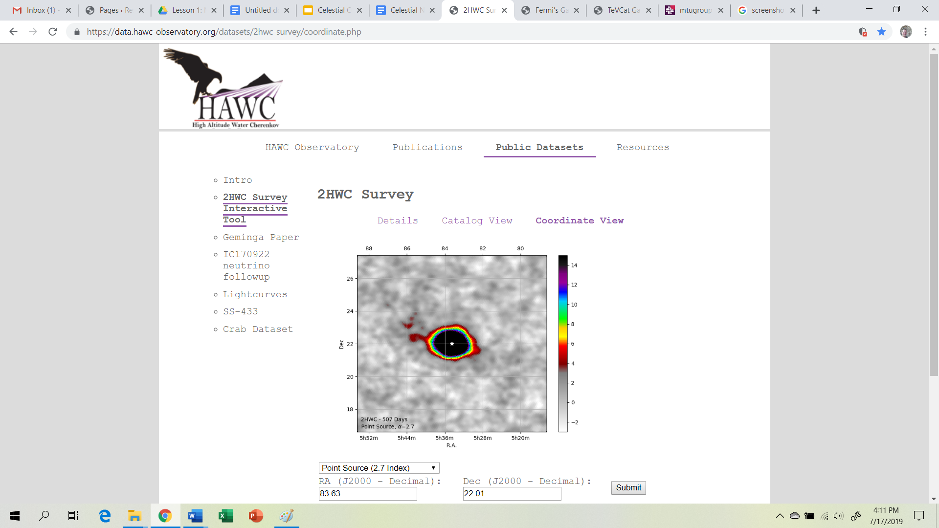

Once all of the teams are logged into the correct website and have a Race Tracker and calculator the teacher will remind the class of the rules and start the clock.
Note: Some sources will only be visible at 1.0 Deg Extended (2.0 Index) parameters. To change the parameters select the pull down icon on the site below the significance map and select submit.
For a catalog of HAWC significance maps select the Catalog View link above the significance map.

Game Rules:
(1) If you pick it up you must solve it! Teams are not allowed to put a card back if they don’t like the coordinates on the card. Record the Card Number on the Race Tracker.
(2) Only one card at a time! Teams must finish a card and get the answer approved by the teacher before getting another card.
(3) Teams must stay together and solve the problem together! All team members must be together when checking answers.
(4) The Team with the most correct answers at the end of the time WINS!

Suggested Prize would be a Homework Pass.

Key Vocabulary and Academic Vocabulary:
- Declination: the angular distance of a heavenly body from the celestial equator, measured on the great circle passing through the celestial pole and the body.
- Celestial Sphere: the imaginary spherical shell formed by the sky, usually represented as an infinite sphere, the center of which is a given observer's position.
- Celestial Longitude: the angular distance of a point on the celestial sphere from the great circle that is perpendicular to the ecliptic at the point of the vernal equinox, measured through 360°eastward parallel to the ecliptic.
- Latitude: the angular distance north or south from the equator of a point on the earth's surface,measured on the meridian of the point.
- Longitude: angular distance east or west on the earth's surface, measured by the angle contained between the meridian of a particular place and some prime meridian, as that of Greenwich, England, and expressed either in degrees or by some corresponding difference intime.
- Meridian: a great circle of the earth passing through the poles and any given point on the earth's surface.
- Protractor: an instrument for measuring angles, typically in the form of a flat semicircle marked with degrees along the curved edge.
- Right Ascension: the arc of the celestial equator measured eastward from the vernal equinox to the foot of the great circle passing through the celestial poles and a given point on the celestial sphere,expressed in degrees or hours.
- Significance Map: A graphical representation of the quantity of significant data obtained from different respective locations.
Assessment: The Team with the most correct answers at the end of the time WINS! Suggested Prize would be a Homework Pass.

Extension/Cross Curricular:
A possible extension activity would be for the students to determine the name of the celestial object at the given coordinates.

Resources:
“Dictionary.com” (2019) www.dictionary.com. Accessed July 17, 2019.

Instructional Procedure
Heading: Engineering Design Challenge: Portable Planetarium
Elaborate
Goal of the Day
- Students will be able to demonstrate grade-appropriate proficiency in planning and carrying out investigations, designing solutions, developing and using models, and obtaining, evaluating, and communicating information.
Advance Preparation:
- Bell ringer on the board: What is a portable planetarium?
- Available resources (See attached Available Resources Cost sheet) Note: The resources provided to the students from the school may vary.
- Engineering Design Process Scoring Rubric
- Protractor for each student
Background Information (Lesson Introduction):
Engineering Design Challenge:
- Set a Goal and Define the problem.
  - Identify the customers needs/requirements. This should be a list of criteria and constraints for the solution.
  - Identify available resources.
  - Identify the key performance criteria
    - Quality: Reliability, Adaptability.
    - Safety: Prevent damage to Humans, property, and the environment.
    - Cost: The students will be provided with the Available Resources (See the attached Available Resource Cost Sheet). Each of the available resources has an associated “cost”. Students must keep track of the resources they used so that they may stick to a budget of $20. If students wish to bring in additional materials, they are encouraged to bring in recyclable materials. Recycled materials will need to be included on the materials list but will not cost anything in the budget. Students will need to keep track of all of the materials used in their model and the cost associated with them. The cost of materials used may not exceed $20.
    - Environmental Impact: Durability, Repair, and Disposal.
- Imagine and Research
  - Compile physics concepts and vocabulary.
  - Determine what is available that would be competitive with your product.
  - Generate multiple ideas for the solution.
- Process and Plan
  - Compare and contrast methods and ideas.
  - Examine possible trade-offs to help reach goals and maximize efforts.
  - Select a solution.
  - Evaluate Work to date.
- Create
  - Create a model.
- Test
  - Design and conduct an experiment to test the suitability of the model.
- Improve
  - Make needed changes.
- Output; a way to Share your solution.
  - Present the results and the selected solution.
- Feedback
  - Obtain responses from target audience regarding the appropriateness of meeting the customers needs.

Wave-particle duality of light and shadows:
Light can be described with two different types of models; a wave model or a particle model. The wave model was accepted after the Young’s Interference Experiment of 1801. The experiment consisted of passing light through a series of slits so that the light demonstrates phase relationships of constructive or destructive interference. Constructive and destructive interference are products of wave properties, notably wavelength and amplitude. Electromagnetic radiation also has properties of particles.
Electromagnetic radiation is also modeled as a photon, a mass-less package of energy that has momentum. The photon of light travels in straight lines, like particles, until refracted, reflected, obstructed, deflected, or absorbed. This property of light leads to the idea of light rays. Shadows cast by object from the sun change as the angel from the sun to the object change. Light rays travel straight from the sun to the object and ground respectively. As the angle of these objects change (earth rotation) the size and properties of the shadows change. Shadows have an umbra, a part of the shadow that does not receive any light and a penumbra that is fuzzy looking and receives only light partially. These properties of light will make this Engineering Design Challenge more challenging.

Procedure/Strategies: Elaborate
-Engineering Design Challenge (5 class periods):
- Goal: The customer wants a portable planetarium that is less than 40lb. The Portable Planetarium must have an accurate RA and Dec coordinate system. Correctly depicts 8 major celestial object (Ursa Major, Ursa Minor, Sirius, Betelgeuse, Orion’s Belt, Crab Nebula, Mrk 421 and Mrk 501). The Portable Planetarium must also be capable of showing 3 Gamma-ray constellations (https://fermi.gsfc.nasa.gov/science/constellations/).
- Available Resources: The students will be provided with the Available Resources (See the attached Available Resource Cost Sheet). Each of the available resources has an associated “cost”. Students must keep track of the resources they used so that they may stick to a budget of $20. If students wish to bring in additional materials, they are encouraged to bring in recyclable materials. Recycled materials will need to be included on the materials list but will not cost anything in the budget. Students will need to keep track of all of the materials used in their model and the cost associated with them. The cost of materials used may not exceed $20.
- Quality: The Portable Planetarium must be able to be used a minimum of three times.
- Safety: The Portable Planetarium may not be dangerous to people, and may not cause any damage to property.
- Cost: The students will be provided with Available Resources (See the attached Available Resource Cost Sheet). Each of the available resources has an associated “cost”. Students must keep track of the resources they used so that they may stick to a budget of $20. If students wish to bring in additional materials, they are encouraged to bring in recyclable materials. Recycled materials will need to be included on the materials list but will not cost anything in the budget. Students will need to keep track of all of the materials used in their model and the cost associated with them. The cost of materials used may not exceed $20.
- Environmental: The Portable Planetarium should be made up of recyclable material.

Key Vocabulary and Academic Vocabulary:
- See above.
Assessment:
Engineering Perspective Presentation
The presentation will have several parts that will all work together including the graphs or tables, the demonstration, and the dialog. Each of these can be the responsibility of different team members.
Minimum 7 slides. One slide minimum for each Ask, Imagine, Plan, Create, Test, Improve, and Feedback (Question answer section of your presentation).
The presentation will need to include a demonstration of the model.
There must be a minimum of two graphs or tables. One of the graphs or tables must be on the Test page related to the relevant physics principle.
See attached Engineering Scoring Rubric.

Resources:

Eisenkraft A. Active Physics A Project-Based Inquiry Approach. Physics for All. Third Edition. It’s About Time. 2016. Mount Kisco, New York.

Acknowledgements
This lesson was created through the support of Michigan Technological University’s Physics Department. The Physics Department sponsored a Research Experience for Teachers, which allowed the author to partner with scientists and post-secondary students working in the Michigan Tech group of the larger HAWC (High-Altitude Water Cherenkov Gamma-Ray Observatory) collaboration on gamma-ray astrophysics.

