Observations of the Electromagnetic Spectrum: Lesson Plan
By Matt Laird and Heather Murphy
Last Modified July 2019

Subject(s):
STEM
Astronomy
Physics
Earth and Space
Physical Science

Grade(s):
9th to 12th grade students.

Time:
Five 50 minute class periods

Standard(s): These performance expectations have been directly taken from the Next Generation Science Standards website at https://www.nextgenscience.org/.

HS-PS2-6: Communicate scientific and technical information about why the molecule-level structure is important in the functioning and designed materials.
HS-SP4-4: Evaluate the validity and reliability of claims in published materials of the effects that different frequencies of electromagnetic radiation have when absorbed by matter.
HS-PS4-5: Communicate technical information about how some technological device uses the principle of wave behavior and wave interactions with matter to transmit and capture information and energy.

Connections to Prior Learning:
- Electromagnetic Spectrum (See Multiwavelength Astronomy: Lesson Plan)
- Objects in Space (See Star Evolution and Gamma Ray Sources)
- Observing Radiation (See Multiwavelength Astronomy: Lesson Plan)

Concept/Topic to Teach:
- Observation vs Inference
- Electromagnetic (EM) Spectrum
- Radio Wave detector
- Electrical Circuits
- Wave-particle duality of electromagnetic radiation.
Specific Objectives: Student will be able to…
- Differentiate different types of EM radiation as seen in the Universe.
- Justify the need for different instruments used to measure EM radiation from the Universe.
- Identify the importance of utilizing different instruments to solve scientific problems.
- Create a device to transmit detect radio waves.
Lesson Relevance:
- Demonstrate the relationship between scientific observations and advances in technology in astronomy.
- Compare and contrast the different qualities that determine the detection of the EM Spectrum.
- Transmit and observing EM Spectrum in the form of a radio wave.
- Create and utilize a basic electrical circuit.

Cross Curriculum Connections:
- Electronics/Circuitry: Final Project involves wiring and circuitry.
- History/English: Short report diving into the history of satellites, observatories and telescopes.

Required Materials:
- Computer with Internet Access.
- Components needed for chosen Radio Transmitter and Receiver.
Technology:
- Wiring simple circuits or complex component based circuit boards.

Modification/Accommodation(ELL/IEP students):
- Guided notes/Printed Google Slides Presentation.
- Reduction of Assignment (choose one EM spectra).
- Additional time for the assignment.
- Provide list of useful Vocabulary.
- Pairing with strong anchor student for project work.
Reteach/Extensions(struggling/advanced students):
- Reteach: Guided notes/Printed Google Slides Presentation.
- Reteach: Reduction of Assignment (choose one EM spectra).
- Extension: More advanced Radio receiver project.
- Extension: More in depth report (3 Spectra/2 Instruments).

Instructional Procedure: Engage
Heading: Observation/Inference of the Flat Earth Basketball

Goal of the Day:
- Student will be able to identify the difference between observation and inference.
- Student will be able to note how different types of observations yields a more complete picture.
Advance Preparation:
- Ready the ‘Observations and Inferences’ Google Slides Presentation.
- Have students pull out a piece of paper and pencil so they can write down three observations and three inferences for the image in the Presentation.
- Bell Ringer: Have you ever been confused by an image before?

Background Information (Lesson Introduction):
N/A

Procedure and Strategies:
Show ‘Observations and Inferences’ Google Slides Presentation with time between slides for students to write down observations and inferences based on the images. Have students discuss what they see (observation) and why they believe it is what they see (inference).

Key Vocabulary and Academic Vocabulary:
- Inference: A conclusion reached on the basis of evidence and reasoning.
- Observation: The action or process of observing something or someone carefully or in order to gain information, usually either quantitative or qualitative.
- Qualitative: Relating to, measuring, or measured by the quality of something rather than its quantity.
- Quantitative: Relating to, measuring, or measured by the quantity of something rather than its quality.

Assessment Format:
N/A

Resources:
Imgur. “Behind the Scenes: Flat Basketball Proof.” Imgur, 11 June 2018, imgur.com/gallery/nSGtPtz.

Instructional Procedure: Explore
Heading: A Spectrum of Stellar Observation

Goal of the Day:
- Student will be able to observe the universe in different EM bands.
- Student will be able to explain different satellites that function in different EM bands.

Advance Preparation: Bell Ringer: Name a famous telescope.

Background Information (Lesson Introduction):
“The night sky has always served as a source of wonder and mystery to people. However, it has only been in the past few decades that we have truly begun to 'see' the Universe in all its glory. This is because we have only recently been able to look at the Universe over the entire electromagnetic spectrum. Our Universe contains objects which produce a vast range of radiation with wavelengths either too short or too long for our eyes to see.”
“Instruments which examine all parts of the electromagnetic (EM) spectrum have been available to us only in the 20th century, since the rocket age was required to get instruments sensitive to the infrared, ultraviolet, X-rays, and gamma-ray wavelengths above the Earth. (This "view from space" is extremely important since radiation in these wavelengths is absorbed by the Earth's atmosphere).”

Procedure and Strategies:
- Students will be directed to http://www.chromoscope.net/, where they can explore the universe in different EM spectrums. To change the spectrum use the selection bar in the upper right corner of the screen. Have students go between different spectrums and explore, trying to find points of interest.
- Once students are finished exploring, have them decide on their two favorite EM spectrums and write them down.
- Once the students have decided their favorites, assign two short reports to each student. The reports will be about an instrument that observes in their favorite wavelengths. The reports will have three sections each. (hint: the bottom left corner of the website indicates what satellites were used to create the image)
  - Introduction and brief description about the chosen wavelength
  - Description of an instrument that observes in the wavelength including interesting schematics and history.
  - Interesting discoveries made by the instrument. If the instrument is not operational yet, then purpose for the instrument.

Key Vocabulary and Academic Vocabulary:
- Electromagnetic Spectrum: The range of frequencies (the spectrum) of electromagnetic radiation and their respective wavelengths and photon energies.

Assessment Format: Summative:
Two short reports on an instrument that works in a given wavelength, 1-2 pages in length.

Resources:
“Chromoscope.” Chromoscope, www.chromoscope.net/.

“Electromagnetic Spectrum.” Wikipedia, Wikimedia Foundation, 21 July 2019, en.wikipedia.org/wiki/Electromagnetic_spectrum.

NASA, NASA, imagine.gsfc.nasa.gov/science/toolbox/multiwavelength1.html.

Instructional Procedure: Explain
Heading: Tools for Observing the Stars

Goal of the Day:
- Student will be able to compare and contrast different instruments used to make observations about celestial objects, that are not observable by eye.
Advance Preparation:
- Google Slides Presentation Tools for making observations.
- Guided notes or copies of slides as needed

Background Information (Lesson Introduction):
The intent of this presentation is to illustrate the instruments that observe electromagnetic radiation within the field of astronomy. Only a small range of the electromagnetic spectrum is directly observable to the human eye. Yet celestial objects emit more types of electromagnetic radiation than just visible light. Observing and studying celestial objects is further confounded by the distance these objects are from Earth. Astronomers from around the world have collaborated and applied technological solutions for both of these obstacles. As a result they have and plan on having remarkable instruments that can answer many far reaching questions.
Radio waves are not affected by the Earth’s atmosphere. This allows radio telescopes to be located on the ground. Radio telescopes can also be linked to one another forming an array or interferometry. By combining the data from radio telescopes on different parts of the Earth the resulting image is more detailed. An example of this would be the Event Horizon Telescopes (EHT). One obstacle to radio wave astronomical observations is the location of humans transmitting radio wave signals. Therefore it is important to locate radio telescopes in remote locations so that human activity does not interfere. An increasing issue associated with radio telescope observations is the increase of satellites placed into orbit around Earth that use radio waves to communicate or for navigation purposes. As more and more satellites are placed into orbit it becomes increasingly difficult to obtain radio images that are not affected by the ‘noise’ created.
Microwaves are obscured by the Earth Atmosphere so observations within their range of the electromagnetic spectrum are only possible from outside the atmosphere. As a product of, what is theorised to be, the Big Bang Explosion there is cosmic microwave background (CMB) at about 3K (Kelvin) distributed everywhere in the cosmos.
Infrared radiation can be blocked by water molecules in Earth’s atmosphere. Therefore, any infrared observatory must be either at high altitudes or outside the atmosphere in orbit. An issue that confounds infrared detection is the correlation between heat and infrared radiation. Detectors have to be designed to account for infrared background both in the immediate surroundings, and from the heat created by the operation of the detector itself.
Visible light spectrum is observable on Earth’s surface but it is not immune from atmospheric influences. Weather and light pollution are two examples of environmental influences that can obscure the clarity of visual light images. These can be reduced by having telescopes at remote high altitudes or in orbit, like the famous Hubble telescope.
Ultraviolet radiation is absorbed by the Earth’s atmosphere, so in order to observe this region of the electromagnetic spectrum the observatory must be positioned outside the atmosphere in orbit.
Observatories for x-rays are difficult not only for their location, needing to be above the Earth’s atmosphere, because x-ray radiation is absorbed by the Earth’s atmosphere. But also, for the fundamental properties of x-rays. X-rays have short wavelengths and high energy, so they have a tendency to travel through materials rather then being reflected, like longer wavelengths of electromagnetic radiation. X-ray observatories need to be constructed with long focal lengths and with detectors sensitive to electron volts (eV).
Gamma Rays are even more difficult to detect directly because the have the shortest wavelength and the highest energy of the electromagnetic spectrum. These properties of gamma rays results in them not being directly detectable on Earth, because they are absorbed in the Earth’s atmosphere. Astronomers (Astrophysicists) have overcome this obstacle by creating observatories like the High Altitude Water Cherenkov (HAWC) Observatory that detect the chain-reaction of cascading particles known as the extensive air shower produced by gamma rays as they enter the atmosphere. Properties of these extensive air showers indicate the type, energy, and direction of the primary gamma ray. The number of particles within the air shower peaks at higher altitudes within the Earth's atmosphere so the HAWC observatory is located at an altitude of 4100m. (See Cosmic Gamma Rays: Lesson Plan)
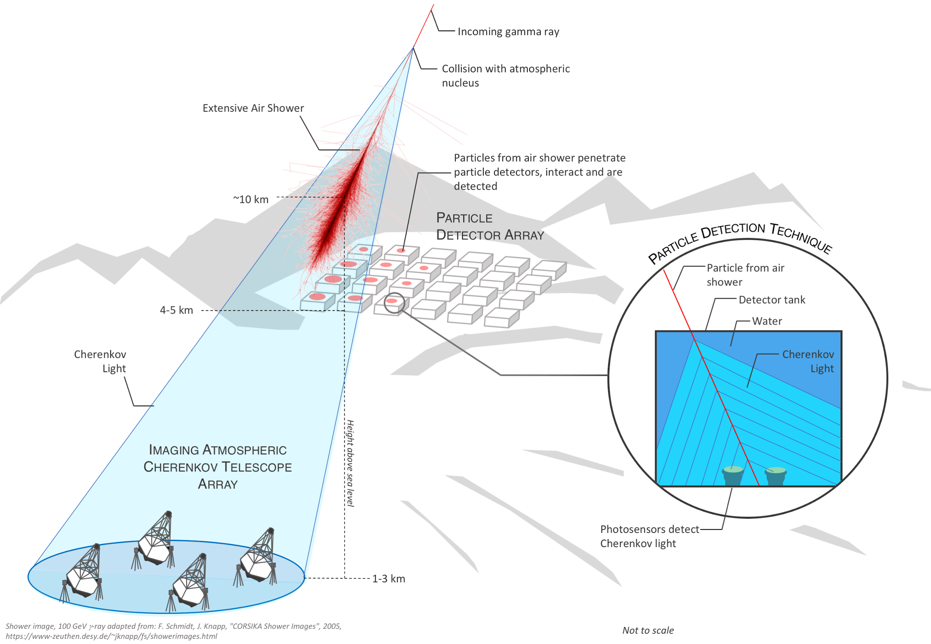

Procedure and Strategies:
The following is a list of the instruments used and the range they detect within the Electromagnetic spectrum.
SKA: Radio
VLA: Radio
Hubbell: IR and Visible
Herschel: IR
Sofia: IR
EHT: IR
Webb: IR
MPG: IR and Visible
W First: IR
Chandra: X-Ray
Fermi: Gamma
HAWC: Gamma
LIGO/VIRGO: Grav Waves

Key Vocabulary and Academic Vocabulary:
- Gamma rays: The type of radiation that has the shortest wavelength and the highest energy. Some radioactive materials give off gamma rays.
- Infrared radiation: the type of radiation that has wavelengths longer than the red end of visible light, but shorter than microwaves, with wavelengths between 1 and 100 micrometers. Infrared radiation is felt in the heat of the sun. These waves are also used in TV remote controls.
- Interferometer: an instrument for measuring the angular separation of double stars or the diameter of giant stars by means of the interference phenomena of light emitted by these stars.
- Microwaves: The type of electromagnetic radiation that has a wavelength between 1 millimeter and 30 centimeters. Microwave energy can be used to heat food, as in a microwave oven.
- Radio waves: The type of electromagnetic radiation that has the longest wavelength and the lowest energy, and carries radio, TV and Cell Phone signals. Radio wave may be as long as a football field or as short as a football.
- Ultraviolet radiation: The type of radiation that is shorter than the violet light that humans can see. This type of radiation can cause a sunburn.
- Visible light: Radiation that human eyes can see. People see the longest wavelengths, which are about 700 nanometers, as the color red. The order of the remaining colors from longest to shortest wavelengths is orange, yellow, green, blue indigo, and violet. Violet has the shortest wavelength of about 400 nanometers.
- Wavelength: Distance from peak to peak of a wave.
- X-rays: the type of radiation that has high energy and can be used by doctors to see bones inside the body.

Assessment Format:
Group discussion or quiet reflection exit ticket. Students should answer the question Why do astronomers need so many different types of telescopes?

Resources:
HAWC Collaboration. Detecting Cosmic rays. HAWC. https://www.hawc-observatory.org/science/detection.php Accessed July 25, 2019

Smale A. Observatories Across the Electromagnetic Spectrum National Aeronautics and Space Administration Goddard Space Flight Center. NASA
https://imagine.gsfc.nasa.gov/science/toolbox/emspectrum_observatories1.html Accessed July 24, 2019

Smith H. R. What Is the Fermi Gamma-ray Space Telescope? NASA Knows! (Grades 5-8) series. NASA. Feb. 8, 2017. https://www.nasa.gov/audience/forstudents/5-8/features/nasa-knows/what-is-the-fermi-telescope-58.html Accessed July 23, 2019

Instructional Procedure: Elaborate
Heading: Radio Transmitter and Receiver

Goal of the Day:
- Student will be able to communicate technical information about how a telegraph transmitter uses the principle of wave behavior and wave interactions with matter to transmit and capture information.
Advance Preparation:
For the Telegraph (Radio Wave Transmitter)
- Board or base to fasten the telegraph to
- Five strips of any metal (Copper plated hanging strips)
- Two D batteries
- Two nails
- Wire (copper)
- Eight screws (Shorter than the thickness of the board)
Note: if you are using a battery holder you will need two less metal strips and two less screws.
Coherer Detector (Radio Wave Receiver)
- Plastic insulated ballpoint pen barrel or transparent plastic tubing
- Two Nails of the same length that fit snugly into the tubing (electrodes)
- Two D batteries
- Wire (copper)
- Light bulb (light cut from christmas tree lights)/ Speakers/ headphones
- Nickel, silver, or iron filings
Alternative setup (Radio Wave Receiver)
- Antenna
- Wire
- Ground
- Diode
- speakers/headphones/light bulb/fan
Alternative to the alternative radio receiver
- Radio set to AM station

Background Information (Lesson Introduction):

This lesson is focused on the detection of electromagnetic waves, for observation. What better way to demonstrate the detection of electromagnetic waves then to have the students produce the electromagnetic waves (Radio waves) that they then detect. The students will make a telegraph that creates the radio waves that will then be detected by a simple coherer energy detector.
This early style telegraph generates a radio wave signal by producing a spark when the circuit is completed. This allows the operator to generate radio waves by connecting and disconnecting the circuit respectively. Radio waves are produced by the spark. When there is a spark, electrons are transferred from one electrode to another as the electrons move, energy is transferred into heat, light, and a standing wave at the frequency of a radio wave. In this design the switch is a piece of metal that is depressed to make contact with the wire, and released to open the circuit breaking the connection. (See photograph below) This circuit can be opened and closed easily in a pattern known as Morse code to send information wirelessly.

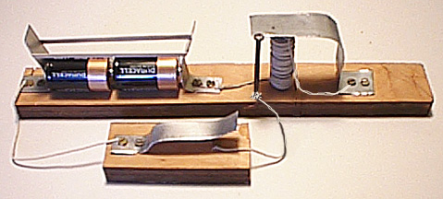
Photograph taken from Perera T. Website.

A coherer detector is a historic radio wave detector made of common everyday materials. It consists of a tube containing some metal filings and two electrodes within millimeters of each other. Each electrode is connected to an observable resistor like a light bulb, speakers, or headphones. In the presence of a radio wave the metal filings form a bridge that completes a circuit within the detector. When the circuit is closed the radio wave becomes observable, success! The tube needs to be tapped so that the metal filings will decoher and the detector is primed to detect another transmission. The cohere detector requires attention to make the metal filings decohere and therefore has since been replaced with less limited detectors.
In the resources section below see alternative radio transmitters and receivers and select the most appropriate model for the needs and resources of your classroom.

Procedure and Strategies:

Students will need to construct a wireless telegraph and a Coherer energy detector. They will then use these to send a signal via morse code to the other device.

Key Vocabulary and Academic Vocabulary:
- Electrode: a conductor, not necessarily metallic, through which a current enters or leaves
- Radio waves: The type of electromagnetic radiation that has the longest wavelength and the lowest energy, and carries radio, TV and Cell Phone signals. Radio wave may be as long as a football field or as short as a football.

Assessment Format:
Students will need to compete and submit the laboratory assignment.

Resources:
Construction & Operation of the Coherer. Electronics Notes Incoporating Radio-Electronics.com. https://www.electronics-notes.com/articles/history/radio-receivers/coherer-construction-operation.php Accessed July 25, 2019

ElectricSpace in Workshop Science. Make a Radio Telescope With Raspberry Pi. Instructables Workshop. 2019. https://www.instructables.com/id/Make-a-Radio-Telescope-With-Raspberry-Pi/ Accessed July 25, 2019

Gass J. Radio Jove Help/ How. NASA. March 19, 2018. https://radiojove.gsfc.nasa.gov/help/index.html#setup Accessed July 25, 2019

Malanski S. & Malanski M. Build your own radio telescope. Science in Schools The European Journal for Science Teachers. Issue 23. May 22, 2012. https://www.scienceinschool.org/2012/issue23/telescope Accessed July 25, 2019

Perera T. HOW TO BUILD A SIMPLE WIRELESS TELEGRAPH SET. Montclair State University. Telegraph Web Page. http://www.w1tp.com/perwirls.htm Accessed July 22, 2019

Procedure/Strategies:
Assessment:
Acknowledgements
This lesson was created through the support of Michigan Technological University’s Physics Department. The Physics Department sponsored a Research Experience for Teachers, which allowed the author to partner with scientists and post-secondary students working in the Michigan Tech group of the larger HAWC (High-Altitude Water Cherenkov Gamma-Ray Observatory) collaboration on gamma-ray astrophysics.

