## Background Information

### What is a cloud chamber?

The cloud chamber dates back to 1911 when Scottish physicist Charles Thomson Rees Wilson created an expansion chamber to produce and study clouds (for which he won the Nobel Prize in 1927). Wilson’s chamber worked on expansion - rapidly expanding the chamber volume results in a decrease of temperature. This allowed for condensation to occur and the water vapor formed clouds. This is the same thing that happens when you open a cold bottle of pop on a warm day; that mist you see inside the bottle just above the liquid is the same thing Wilson was doing with water. This form of chamber - expansion chambers, require the constant expansion and contraction cycle to work. However, in 1936 the American physicist Alexander Langsdorf created the diffusion cloud chamber. The diffusion chamber relies on a temperature gradient instead of expansion to produce a cloud. By cooling the bottom of the chamber to a very low temperature (using dry ice, compressed air, or electric coolers), the vapor at the top of the chamber will condense as it falls and nears the bottom of the chamber, producing the cloud. Because diffusion chambers contain cooler temperatures than the original expansion chambers, alcohol is substituted for water because of its lower freezing point.

### How does a cloud chamber work to detect particles?

When energetic charged particles enter the chamber, they ionize molecules within the chamber. This means that the charged particles have enough energy to rip electrons from atoms, leaving the ionized atoms slightly charged themselves. The alcohol used in the system is attracted to these ions, and create thicker clouds than the rest of the chamber. Because the original charged particles are moving (very quickly), a trail of ions is left, and this creates a thicker cloud track than what’s visible in the cloud chamber. Effectively, tracks are made, much like the contrails of an airplane traveling through the sky.

### What is a cloud chamber used for?

Today, cloud chambers are used predominantly for demonstration purposes. However, cloud chambers were a vital part of particle physics from the 1920s to the 1950s. Cloud chambers allow us to view otherwise invisible particles. These energetic charged particles can originate from radioactive sources here on Earth or naturally from the universe. We know from grade school that charged particles are electrons and protons. Indeed, these two types of charged particles can be observed in a cloud chamber but so can many other energetic particles. In the thirty years of scientific use, cloud chambers were instrumental in detecting and measuring several particles that until then had only been theorized. Two significant examples of this are the positron (1932) and the muon (1936), both discovered by American physicist Carl David Anderson.

## Safety Concerns

Isopropyl alcohol is a highly flammable liquid whose vapors are explosive. There should no sources of open flames or sparks in the classroom when using isopropyl alcohol, and the alcohol should be used in a **fume hood** or **well ventilated space**. Isopropyl alcohol is also hazardous to humans, especially through inhalation and ingestion, as well as through contact with skin and eyes. Students should handle the alcohol with care, use **gloves** and **safety glasses**, and only under **adult supervision**. Symptoms of inhalation/ingestion may include (but is not limited to) dizziness, drowsiness, headache, and abdominal pain. Treatment of exposure includes fresh air (inhalation), or rinsing the mouth (ingestion). If isopropyl alcohol comes in contact with skin, drying can occur; if it comes in contact with eyes, redness can occur. In both instances, rinse the affected area with plenty of water.

*Dry ice* is solid carbon dioxide. Carbon dioxide is hazardous to humans if inhaled, and so dry ice should be used in a **well ventilated space**. If inhaled, humans may experience dizziness, headaches, and increased heart rate. In the event of inhalation, move the person to a space with significant amounts of fresh air and have them rest. Medical guidance may be sought for severe cases. Additionally, solid carbon dioxide is extremely cold (-109℉/-79℃) and causes immediate frostbite burns if it comes in contact with the skin or eyes. These effects can be easily compounded in the likely event the dry ice sticks to skin. Therefore, students should handle the dry ice with extreme care, and use **gloves** and **safety glasses**, and only use with **adult supervision**. In the event of frostbite (due to contact), rinse the affected area with plenty of water.

*As with all hazardous materials, communicate any exposure to the person in charge immediately. Seek medical advice if needed.*

## Materials

* Isopropyl Alcohol (91%)
* Dry Ice
* Clear Plastic Container
* Absorbent Material (Suggested: Cotton Batting, Felt, Sponge)
* Rubber Cement
* Play-Doh
* Metal Baking Cake Pan (Should be only slightly larger than the clear plastic container)
* Black Paint (Matte Finish)
* Flashlight
* Optional: Radioactive Source
  + Thoriated tungsten electrodes (“welding rods” containing 2% thorium)
  + Piece of Fiestaware (made between 1936 - 1972). Red/orange is the recommended color(s).

## Procedure

1. Prepare the metal baking cake pan by turning the pan over and painting the bottom of the pan with the matte black paint. Set aside to dry.
2. Measure and cut out the absorbent material so that it fits into and covers the bottom of the clear plastic container. Adhere the absorbent material to the bottom of the clear plastic container using rubber cement.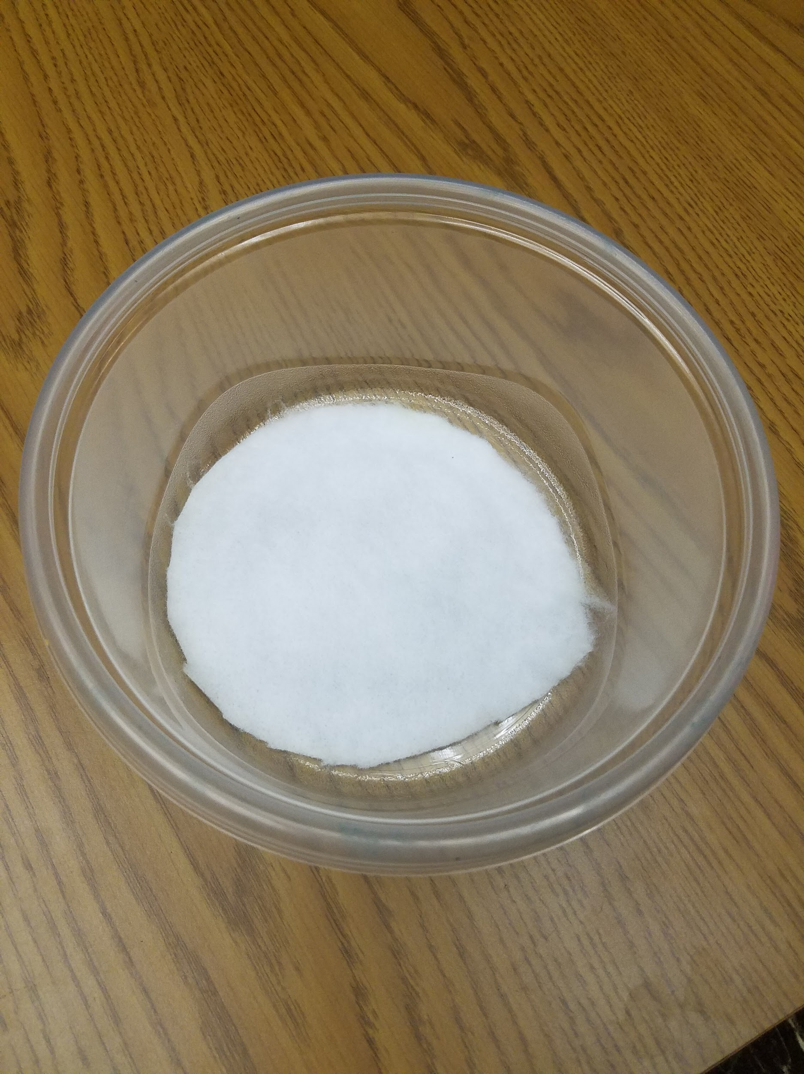
   1. **NOTE:** The rubber cement must dry completely before continuing. ***Steps 1 and 2 should completed a day prior to use.*** The rubber cement will need 24 hours to completely dry and cure. After a day of drying, you should be able to turn the container upside down without the material falling out.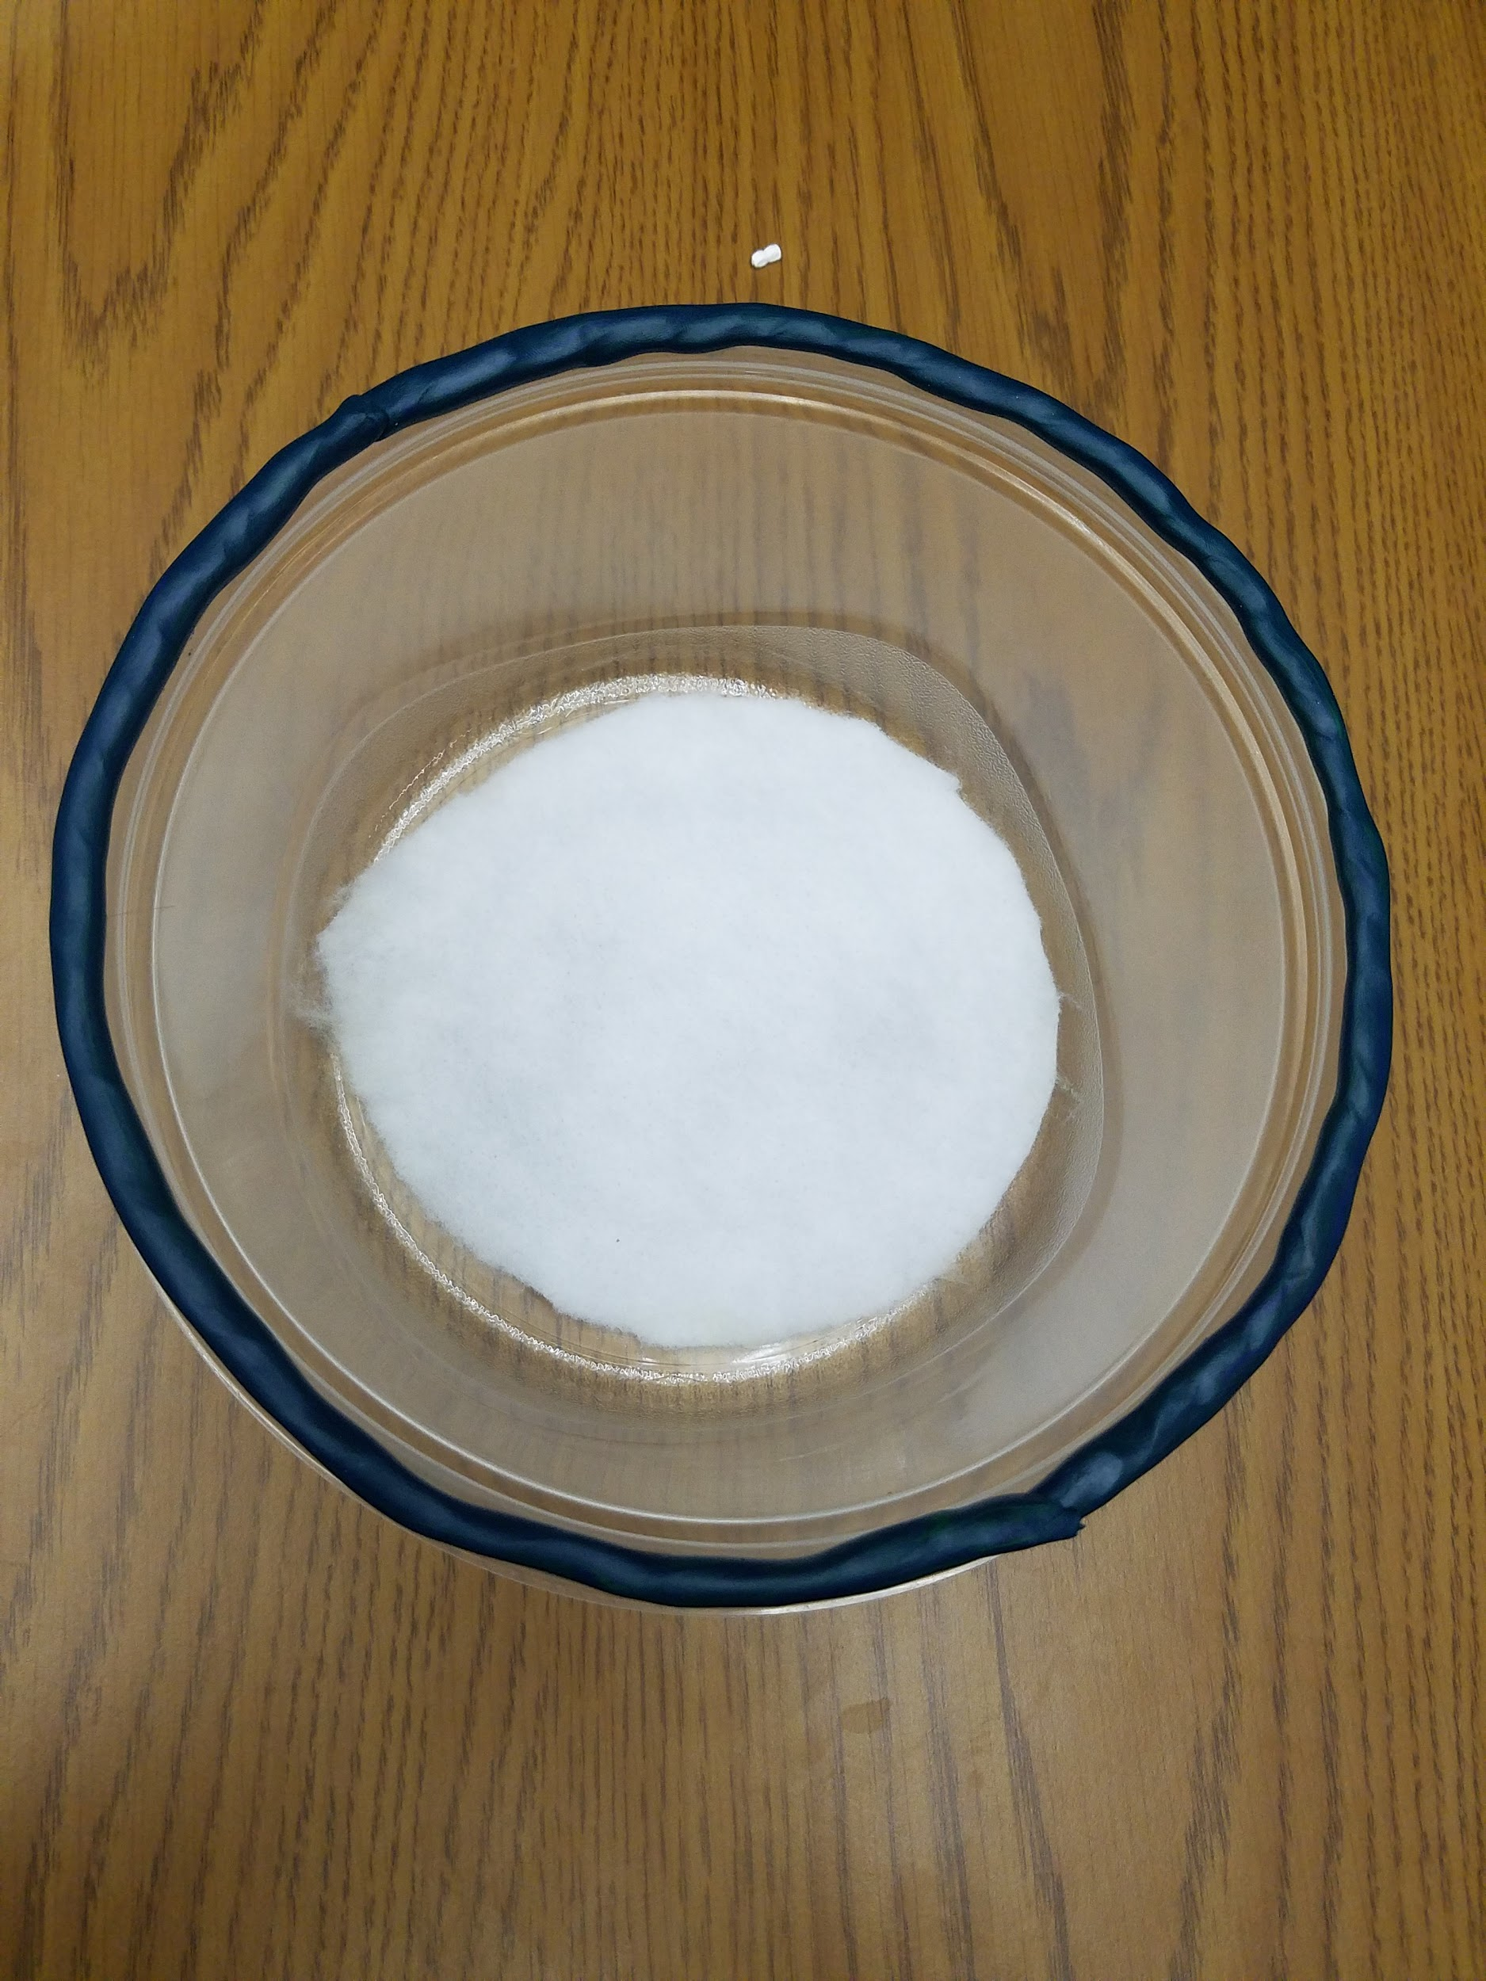
3. Use strips of Play-Doh to trace the top lip of the clear plastic container. This will form your seal, so make sure it is generally even and encompasses the entire lip of the container.
4. Use a syringe or careful pouring to add isopropyl alcohol to the absorbent material at the bottom of the container. The material should be complete saturated but have no standing alcohol. If there is excess alcohol, Carefully drain it onto the edges of of the painted metal pan.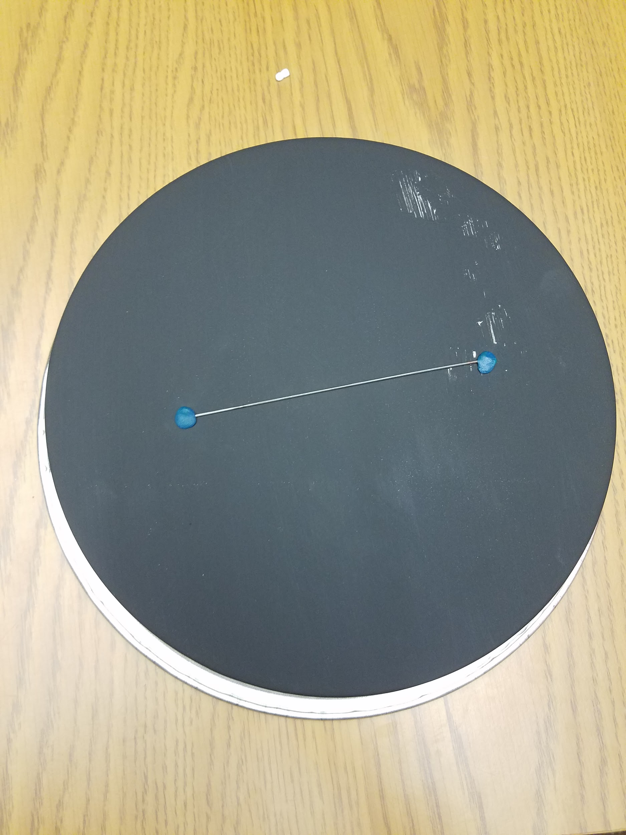
5. **NOTE:** If you are adding a radioactive source, make sure to attach it to the painted side of the metal baking cake pan using small pieces of modeling Play-Doh before completing the next step.
   1. Alternately, you may suspend the sample in the chamber by attaching it (using Play-Doh) to the sides of the container, taking care not to puncture the sides of the chamber. 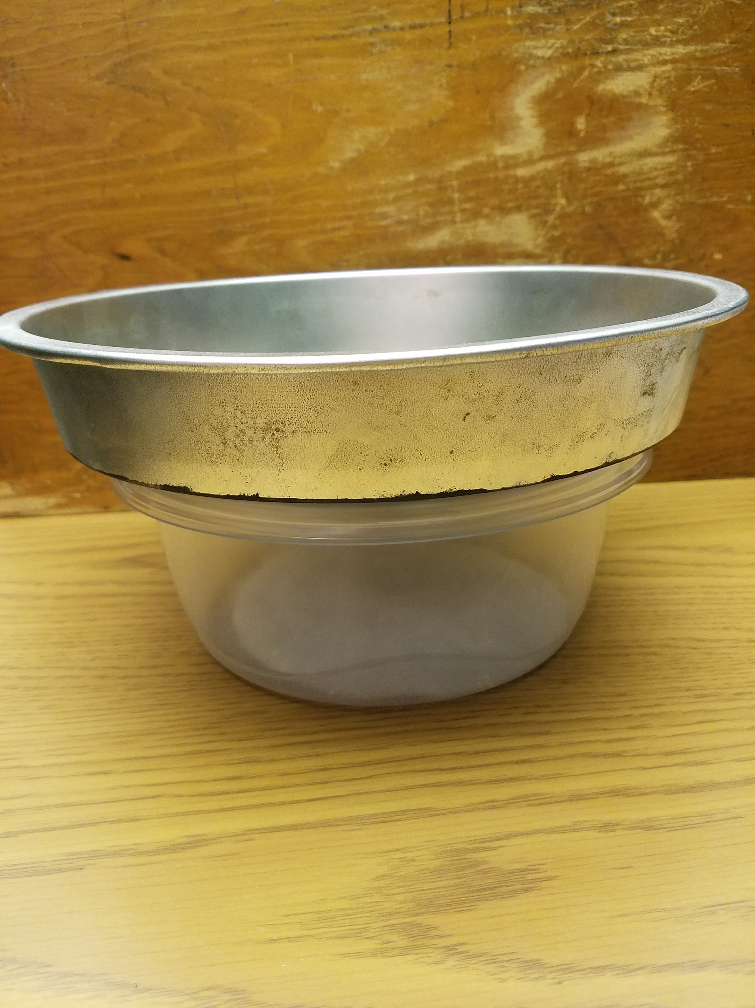
6. Leave the clear plastic container upright and turn the metal baking cake pan so that the painted side (bottom) is down. Place on top of the plastic container and apply heavy pressure to “smush” the Play-Doh.
   1. You are creating a seal with this step - this is very important to have have a successful cloud. Inspect the Play-Doh and make sure there are no leaks between the clear plastic container and the painted metal baking cake pan.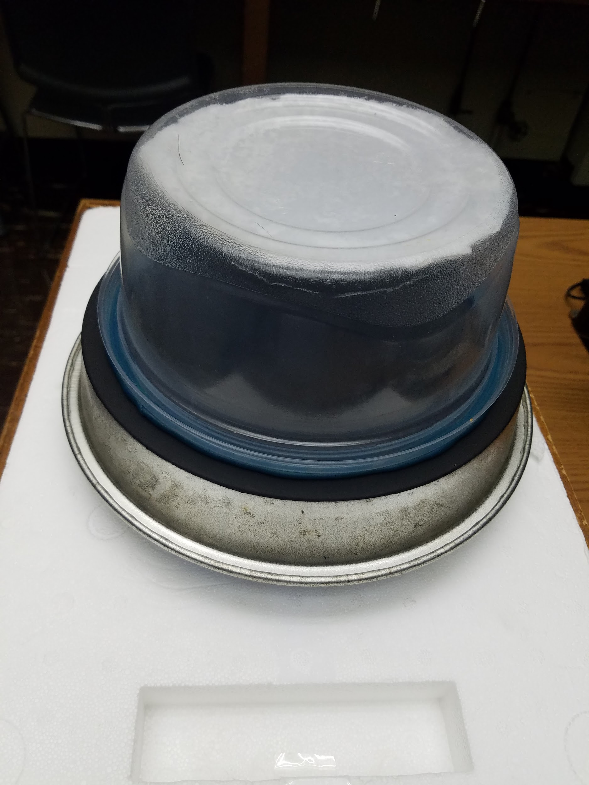
7. Carefully place the dry ice on an insulated tray and turn the cloud chamber right-side up, so that the plastic container and metal pan are upside down. Place the cloud chamber so that the dry ice is underneath and inside the metal pan. Make sure the cloud chamber is level.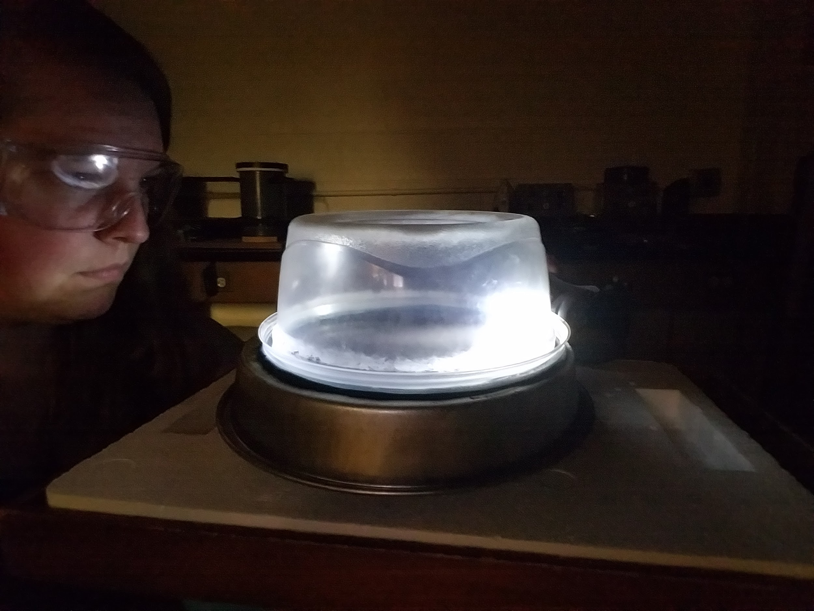
8. Turn off the lights and make sure the room is dark. After several minutes, shine the flashlight through the cloud chamber, so that it is in the same plane as the bottom of the chamber and illuminates the black surface. Adjust the flashlight until the viewer can observe a fine mist at the bottom of the cloud chamber (near the black bottom).
   1. Seeing the mist is an indication that the cloud chamber is sealed and functioning correctly. Be patient and you should begin to see short tracks appear and then dissipate. You now have a working cloud chamber! Go forth and investigate!

## Results

The cloud chamber can observe several different types of particles. A summary of some of the more common particles are described below.

|  |  |  |  |
| --- | --- | --- | --- |
| **Particle/Event** | **Visual Example1** | **Written Description** | **Source or Cause** |
| Alpha |  | *Common*  Short (~2-4 cm),  Thick, & Straight | Contains two protons and two neutrons.  Produced through alpha decay of several radioactive sources as well as cosmic rays. One of the most common source of alpha particles is from naturally occurring radon in the atmosphere. |
| Beta  (Electron)  (Positron) |  | *Very Common*  Various Lengths  Wispy Thin  Straight or Squiggly  Short-lived | Contains one electron or one positron (the antimatter of the electron). In a cloud chamber, the particles will appear identical unless a strong magnetic field is introduced to show deflection. Produced through beta decay of several radioactive sources as well as cosmic rays. |
| Muon |  | *Not as Common*  Long (>10 cm)  Thin & Straight | Similar to an electron/positron but with a much bigger mass, muons are produced from the interaction of cosmic rays with Earth’s atmosphere. Muons are unstable particles which naturally decay in 0.0000022 seconds (2.2 µs). This is unbelievably short and should not be observable if the muons are coming from the top of Earth’s atmosphere. However, because the muon is traveling near the speed of light, Einstein’s Special Relativity rules and the muon experiences a time dilation. This allows some muons to reach the cloud chamber. |
| Muon Decay |  | *Rare*  Thin & Straight  Sudden Break & Thinner | When a muon reaches it’s half-life of 2.2 µs, it decays. The muon decays into two neutrinos and an electron/positron. The neutrinos are neutral, and thus do not interact with the cloud mist. However, the electron/positron is charged, and therefore can be seen in a cloud chamber. If a muon decay is observed in a cloud chamber, it will look like a muon track that suddenly “breaks” or turns into a new direction, and look like the thinner track of an electron/positron. |
| Cosmic Ray Shower |  | *Very Rare*  Several Tracks  Same Time & Direction | Cosmic rays may originate from outer space. While still being actively studied and explored, some sources of cosmic rays may include supernovae (stellar evolutionary endphase of large stars) and quasars (very powerful and energetic objects at the center of active galaxies). When cosmic rays near Earth, they collide with atoms and molecules within the atmosphere. These collisions result in a cosmic ray or air particle shower, which is a chain reaction of particles being broken apart and being created. Some particles are energetic enough not only to produce ions (by ripping off electrons), but to break apart the nucleus of an atom - ripping apart protons and neutrons into smaller particles. These high-energy particles, including alpha particles, electrons, positrons, muons (and others), can reach Earth and some can even be seen in a cloud chamber. |
| Radioactive Source  (Alpha) |  | *Requires Source*  Short, Thick, & Straight  Radiating from Source | Alpha-emitting radiation sources include radium (like that used in pre-1970s watch dials), thorium (like that used in thoriated welding rods), americium (like that used in smoke detectors), and uranium (like that used in pre-1970s fiestaware). Since alpha particles are easily shielded, they can be used in certain consumer products. In alpha decay, a helium nucleus is emitted from the atom. The cloud tracks will look similar to an isolated alpha particle, but more numerous and radiation out from the source. |
| Radioactive Source  (Beta) |  | *Requires Source*  Thin  Radiating from Source | Sealed sources of radioactive material that emit beta particles, such as Strontium-90, Thallium-204, and Tin-113 can be purchased from scientific supply companies. Natural sources of beta radiation include Carbon-14 (like that used in carbon dating) and Potassium-40 (like that found in bananas and salt substitutes). Because beta particles are not as easily shielded (compared to alpha particles), they are not typically used in commercial products, however there are low levels of beta radiation in potassium chloride (a salt substitute). In beta decay, electrons (and positrons) are emitted from the atom. The cloud tracks will look similar to the tracks of isolated electrons, but be much more numerous and radiating out from the source. |
| Radioactive Source (Gamma) |  | *Requires Source & a Quality Cloud Chamber*  Tiny & Thin | Sealed sources that emit gamma radiation include Sodium-22, Cobalt-57, Barium-133, Manganese-54, Cesium-137, Cobalt-60, Cadmium-109, and Zinc-65 can be purchased from scientific supply companies. Gamma radiation occurs when the radioactive nucleus gives off high-energy photons of (electromagnetic) radiation. Because gamma rays are neutral, they will not interact with the cloud mist. Gamma radiation can interact with materials, and potentially ionize particles within that material. It is possible to see these electrons that have been ripped from molecules within the material (the wall of the cloud chamber). [This event is included so that all types of radiation are discussed, however it is not recommended to try in a typical classroom due to the safety concerns with the radioactive sources and difficulty levels in observing this event, known as Compton scattering.] |

1 Visuals taken from “[Cloud Chambers](https://www.nuledo.com/en/cloud-chambers/#rozpad-mionu-slabou-interakci)” by [Nuledo](https://www.nuledo.com/en/), licensed under [CC-BY-SA 4.0](https://creativecommons.org/licenses/by-sa/4.0/)

## Suggested Student Activities

* Explore naturally occurring background radiation.
  + Calculate background radiation rate by counting particles per unit time.
  + Observe and trace cloud tracks to determine the origin of the background radiation.
  + Compare background radiation for different locations and/or conditions.
* Investigate radiation from active radioactive sources.
  + Estimate the decay rate of a radioactive source (e.g. thorium).
  + Compare radiation of different radioactive sources (alpha, beta, and/or gamma).
* Dive deeper into the particles observed in cloud chambers.
  + Measure the length of alpha particle tracks to determine the distribution of particle energies.
  + Introduce a strong magnetic field to differentiate between electrons and positrons.
  + Experimentally test radiation shield materials for alpha, beta, and/or gamma radiation.

## 

## Troubleshooting

* The absorbent material does not stay on the top of the cloud chamber.
  + The rubber cement needs at least 24 hours to dry and cure. If the rubber cement is still wet and does not hold the material, considering using bits of Play-Doh, brass fasteners, or magnets. Note, the isopropyl alcohol will interfere with most other adhesives (including tape).
* The chamber is not producing a cloud.
  + The biggest reason for this is not having a good seal between chamber and metal plate. Make sure the Play-Doh is room temperature so that you can give it a good “smush” onto the plate. If the plate is too cold, the Play-Doh will harden and not “smush” as much, producing gaps in the seal.
  + Another reason for this is a lack of temperature gradient. The top of the chamber needs to be relatively warm (i.e. room temperature), compared to the bottom of the chamber which needs to be sufficiently cold (i.e. in direct contact with the dry ice). Make sure you still have enough dry ice, and put your hand on the top of the chamber to warm it.
* I seem to have a very weak cloud and I do not see any tracks.
  + Ensure that your dry ice is actively touching the metal plate. Any air gaps between the dry ice and metal plate acts as insulation for the metal plate and it will not get cold enough to produce a strong, consistent cloud.
* I do not see any cloud tracks when using a radioactive source.
  + Some sources of radiation, including alpha particles are easily blocked by a few sheets of paper. As such, they will not be able to go through the clear plastic container. Make sure the radioactive source is completely inside the chamber while maintaining a chamber seal.

## Learn More

For more information about the information contained in this reference guide, please visit:

* Cloud Chambers
  + American Physical Society: <https://www.aps.org/publications/apsnews/201001/physicshistory.cfm>
  + Wikipedia: <https://en.wikipedia.org/wiki/Cloud_chamber>
* Radiation
  + Health Physics Society: <https://hps.org/publicinformation/ate/faqs/radiationtypes.html>
  + World Nuclear Association: <http://www.world-nuclear.org/nuclear-basics/what-is-radiation.aspx>
  + American Nuclear Society: <http://nuclearconnect.org/in-the-classroom/for-teachers/classroom-resources/radiation-sources-for-teachers>
* Cosmic Rays
  + Wikipedia: <https://en.wikipedia.org/wiki/Cosmic_ray>
  + COSMOS - The SAO Encyclopedia of Astronomy: <http://astronomy.swin.edu.au/cosmos/C/Cosmic+Rays>